Bulletin No. 1

The 4th Central Asian Geotechnical Symposium:
Geo-Engineering for Construction and Conservation of Cultural Heritage and Historical Sites
- Challenges and Solutions -

Четвертый Центрально-Азиатский Геотехнический Симпозиум

«Геотехнические проблемы при строительстве и сохранении исторических объектов культурного наследия»

Venue: Samarkand, Uzbekistan
21–23 September 2012 (Friday - Sunday)
Symposium website: (under construction)

We are pleased to announce the 4th Central Asian Geotechnical Symposium to be held in Samarkand, Uzbekistan from September 21-23, 2012.
The previous Central Asian Geotechnical Symposiums was in Astana, Kazakhstan, 2000;Samarkand, Uzbekistan, 2003; Dushanbe, Tajikistan, 2006.
The 4thCentral Asian Geotechnical Symposium intends to discuss and exchange ideas on general characteristics of soils in the region, geotechnical problems as well as conservation of heritage and historical sites.
Samarkand ("Stone Fort" or "Rock Town") is the second-largest city in Uzbekistan and the capital of Samarqand Province. The city is most noted for its central position on the Silk Road between China and the West, and for being an Islamic center for scholarly study. In the 14th century it became the capital of the empire of Timur and is the site of his mausoleum. The Bibi-Khanym Mosque remains one of the city's most notable landmarks. The Registan was the ancient center of the city.
In 2001, UNESCO added the city to its World Heritage List as Samarkand – Crossroads of Cultures.
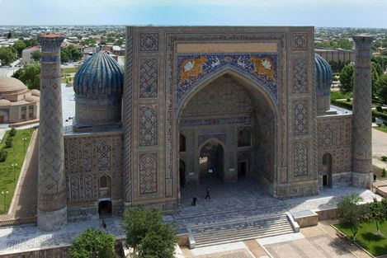
Key date
Submission of Abstract, March 30, 2012
Notice to acceptance, April 30, 2012
Submission of full paper, June 30, 2012
Symposium, September 21-23, 2012
Post Symposium Tour to be arranged

ORGANIZATIONS
- ООО «Geofundamentproject» Samarkand city,Uzbekistan
- ATC19 Conservation of Cultural Heritage and Historical Sites,JGS, ISSMGE
- ATC10 Urban Geo-informatics, JGS,ISSMGE,JGS,ISSMGE
- ATC3 Geotechnologies for Natural Hazards, JGS,ISSMGE
- TC301 Preservation of Historic Sites, IGS, ISSMGE
- TC305 Geotechnical Infrastructure for Megacities and New Capitals,ISSMGE
- Kazakhstan Geotechnical Society,Astana, Kazakhstan
- Commission on Preservation of Ancient Sites, ISRM
- Department of Structural and Geotechnical Engineering, The Samarkand State Architectural and Civil Engineering Institute (SamGASI), Uzbekistan
- The Head of Scientific Production Management of Heritage and Historical Sites of the Republic of Uzbekistan.
- GUP «UzGASHKLITI»,Tashkent City, Uzbekistan
- World Heritage Center, UNESCO

CONFERENCE ADVISORY COMMITTEE
- Prof.Yoshinori Iwasaki, Chair, ATC 19, Conservation of Heritage and Historical Sites, JGS,ISSMGE
- Prof.Jean-Louis Briaud,President of ISSMGE, USA
- Prof.Askar Zhussupbekov, VP of ISSMGE for Asia, Kazakhstan
- Prof.Seco Pinto, Past President of ISSMFE, Portugal
- Prof.Neil Taylor, General Secretary of ISSMGE, UK
- Prof.Calro Viggianni, Chair, TC301, Preservation of Historic Sites, ISSMGE
- Prof.Ikuo Towhata, Chair,ATC3: Geotechnolgies for Natural Hazards,Appointed Board member of ISSMGE, University of Tokyo, Japan
- Prof.Mamoru Mimura, Chair,ATC 10: Urban Geo-Informatics,Kyoto University, Japan
- Prof.V.P.Petrukhin, Director of NIIOSP, Moscow, Russia
- Prof.Vladimir Ulitzky, Chair, TC 207 Soils-Structure Interaction and Retaining Wall,PGUPS, Saint –Petersburg, Russia
- Prof. Khayot Rasulov, State Architectural and Civil Engineering Institute, Department of Geotechnical engineering - Tashkent City, Uzbekistan
- Prof.Tuncer B.Edil, Chair, Department of Civil and Environmental Engineering,The University Wisconsin, Madison, USA
- Prof. Vyacheslav Ilichev,President of Russian Geotechnical Society, Moscow, Russia
- Prof.Kamchibek Kozhogulov, President of Kyrghizstan Geotechnical Society, Bishkek,Kyrghizstan
- Prof.Rustam Usmanov, SPBGASU, President of Tajikistan Geotechnical Society,Tajikistan
- Prof.R.A.Mangushev, Head of Department of Geotechnical Engineering, SPBGASU,Sain –Petersburg, Russia
- Prof.Zuixiong LI, President, Commission on Preservation of Ancient Sites(CPAS), ISRM
- Prof.Claudio Margottini, ISPRA Geological Survey of Italy& UNESCO Consultant
- Prof. Chikaosa Tanimoto, International Institute for Advanced Studies, Kyoto, Japan
- Prof.Fumio Tatsuoka, Tokyo University of Science, Tokyo, Japan
- Prof.Tadatsugu Tanaka, JARUS,Tokyo, Japan
- Prof.Susumu Yasuda, Tokyo Denki University, Japan
- Prof. Kunio Watanabe, Geosphere Research Institute of Saitama University, Japan
- Prof.Xudong Wang, Secretary General, Commission on Preservation of Ancient Sites, ISRM
- Prof.Eun Chul Shin, University of Incheon,Incheon, Korea
- Prof.Hoe Ling, Columbia University, New York, USA
- Dr.Victor Popov, Director of KaragandaGIIZ,Kazakhstan
- Prof.Der Wen Chang,Tamkang University, Taipei, China
- Prof. Kok Kwang Phoon, President of GeoSS, Singapore
- Prof. T.I.Mirsajpov, Head of Dep. of Geotechnical Engineering, Kazan State Architectural and Civil Engineering University, Tatarstan, Russia
- Dr.Michael Lisyuk, PGUPS, Saint–Petersburg, Russia
- Mr.Feng JING, Chief, Asia and the Pacific Section, World Heritage Center, UNESCO

LOCAL ORGANIZING COMMITTEE
Co-Chair:Prof.Askar Khasanov(SamGASI, ООО «Geofundamentproject», Samarkand, Uzbekistan)
Co-Chair:Dr.Ilkhom Usmonkhodjaev (GUP «UzGASHKLITI», Tashkent, Uzbekistan)
General Secretary: Zokhir Hasanov ( ООО «Geofundamentproject», Samarkand, Uzbekistan)
Members:

- Prof.Sultan Akhmedov, Head of State Architectural and Civil Engineering Institute- Samarkand city, Uzbekistan
- Prof. Hayot Rasulov, State Architectural and Civil Engineering Institute - Tashkent City , Uzbekistan
- Dr.Davlat Magrupov, GUP «UzGASHKLITI»- Tashkent City , Uzbekistan
- Dr.Fayzulla Ikramov, State Architectural and Civil Engineering Institute, Department of Geotechnics & Construction Technologies - Samarkand city, Uzbekistan
- Prof.Leonid Nuzhdin,Head of Geotechnical Department, NGASU - Novosibirsk city, Russia
- Dr. Farshed Zehniyev, NIIOSP, Moscow, Russia
- Dr.Rauan Lukpanov, Researcher of KGS,Ltd, member of TC 305, ISSMGE,Astana, Kazakhstan
- Dr.Tursun Zhunisov, Associate Professor of Eurasian National University, Astana, Kazakhstan

THEME AND TOPICS which are related of ATC19, ATC3, ATC10, TC301, and TC305:

The topics in the theme area include:
1. Regional Characterization of Soils and Foundation, andGeo-Construction
2. Adobe, Tomb and Earthen Structures, Historical Sites, and Conservation of Cultural Heritage
3. Regional and Traditional Characteristics of Foundation and Structures
4. Mosque, Minaret, Towers, Citadel, Castles, Stone Masonry,and Heritage Structures
5. AncientCaves, Underground Construction, Tunneling, Transportation, and Infrastructures
6. Ancient and Historical Dam, Embankment, and Ancient Highways
7. Soil Dynamics and Geotechnical Earthquake Engineering
8. Ancient, Traditional, and Present Soil Improvements
9. Damages from Salting and Frost including Geoenvironmental Engineering
10.Traditional and Innovative Technologies for Geotechnical Applications

INVITATION
The Uzbek Geotechnical Society takes great pleasure in inviting all members and Member Societies of ISSMGE Asian region and interested geotechnical engineers and researchers from all over the world to participate in the Conference on Geo-Engineering for Construction and Conservation of Cultural Heritage and Historical Sites of Cultural Heritage and Historical sitesto be held in September 2012 in Samarkand, Uzbekistan.
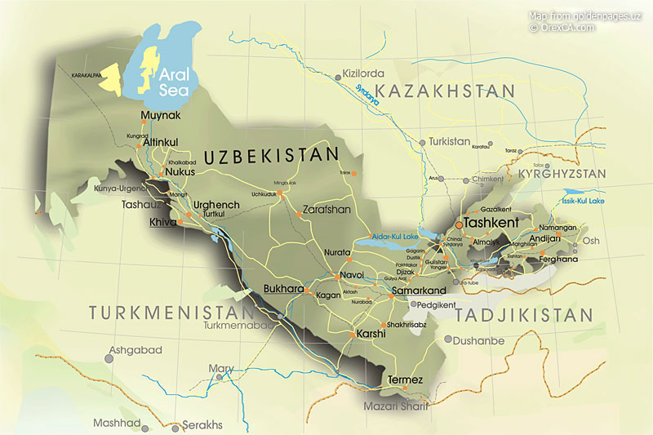

About Uzbekistan
Uzbekistan today is a new independent state in Central Asia. After the collapse of the USSR Uzbekistan chose peace-loving democratic policy and launched reforms to develop a market economy and enter international economic society as a full member.

Uzbekistan at a glanceGeographic coordinates: 41 00 N, 64 00 E
Area: total 447.400 km²: land: 425.400 km², water: 22,000 km²
Land boundaries: total: 6.221 km, border countries: Afghanistan 137 km, Kazakhstan 2.203 km, Kyrgyzstan 1.099 km, Tajikistan 1.161 km, Turkmenistan 1.621 km
Population: 29 million (January, 2011)
Capital: Tashkent
Language Official language - Uzbek, widely used: Russian, Tajik, Kara kalpak, also English, which is getting popular among youth generation.
National currency: Sum. 1 sum=100 tiyin.(1US$=1750 Sum)
Religion: Islam - 88%, Christian - 9%, and other.
Time: GMT + 05:00 SYMPOSIUM LOCATION AND VENUES: Samarkand, Uzbekistan
CALL FOR PAPERS
Prospective authors are asked to submit their abstracts in English of within 300 words with the following information to Zokhir Khasanov: uzssmge@gmail.com
- Name(s) of authors
- Title of the Paper
- Corresponding author
- Telephone, Fax, and E-mail address for correspondence
CONFERENCE FORMAT AND PUBLICATION
The conference will include sessions for presentation and discussion. The working language isEnglish. All papers will be published in the proceedings.
CONFERENCE FEES
Full registration fee for foreign participants: US$ 300
Full registration fee for CIS: US$ 200
The registration fee covers attendance of sessions, lunches, coffee & tea, a copy of the proceeding volume and a tour of heritage and historical sites in Samarkand.
For exhibitors: cost of 1 sq.m. of exhibitors space is US$ 300. Standard exhibition box is 9 sq.m. Special dimension may be discussed.

CONFERENCE WEBSITE
(Under construction)

PRE-REGISTRATION FORM (Please send to Organizing Committee till 30th March,2012)

Please fill out this form in BLOCK letters and return it to:
Zokhir Hasanov:
«Geofundamentproject»
140147,Lolazor St/70, Samarkand, Uzbekistan
Email: uzssmge@gmail.com,
Fax: +998-66 237-00 16 Tel: +998-66 220-2825

First Name:
Surname:
(male / female)
Title(Mr./Ms./Dr./Prof): Position(Director/Researcher/ )
Institution / Organization:
Address:
Postal code:
Email:
Tel: (+country code-)
Fax:
Attendance to the conference: |  Yes |  No
Paper submission: |  Yes |  No
Paper title:

