INTERNATIONAL CONFERENCE ON GEOTECHNICAL ENGINEERING
PREAMBLE

The Pakistan Geotechnical Engineering Society (PGES) takes pleasure in announcing an International Conference to be held in Lahore in March, 2013. This Conference will be 13th event in a row of national and international conferences held under the auspices of PGES.

The theme of the Conference is kept open to attract a diversity of quality papers from around the globe. The Conference will act as a platform for exchange of technical ideas between Clients, Consultants, Contractors and Manufacturers. Outstanding keynote lectures, presentations and technical discussions will provide an excellent opportunity to explore the ever-growing and challenging field of Geotechnical Engineering.

The venue of this Conference is deliberately chosen to be the historical city of Lahore. The City of Lahore is known as educational metropolis of Pakistan in addition of being cultural, entertainment and food hub of the country. Lahore is Pakistan’s largest producer of professionals in the fields of science, technology, IT, engineering, medicines and nuclear sciences. Lahore also offers both historical and cultural attractions, including exceptional Mughal Architecture and many easily accessible cultural tours whether delegates are attracted to world class theatres, museums, cultural attractions, unique shopping areas, exceptional restaurants or thematic neighborhoods, Lahore’s diversity of attractions ensures that there is always something for everyone.

OBJECTIVE

This Conference will provide a great opportunity to the engineers, geologists, seismologists and other professionals engaged in the field of geotechnical engineering, foundation design, construction and manufacturing, to share their expertise in the realm of Geotechnical Engineering. The Conference will help bring together the knowledge available in this field, for future guidance

LOCATION

The conference shall be held in the Auditorium of WAPDA House at Lahore. Lahore is the capital of the Province of Punjab. The climate of Lahore is very pleasant especially in the month of March. The mean daily temperature is from 10 ºC to 20 ºC. Some light woolen clothes may be required.

PROGRAM

The program of the conference will consist of an inaugural session followed by two technical sessions. The organizing committee of the conference expects a very warm response from all the professionals to make this conference a big success.

The detailed program of the conference would be provided in the Final Bulletin.

EXHIBITION

An Exhibition to display the recent developments in geotechnical engineering will also be arranged in the vicinity of conference Hall. Various contractors, consultants and manufacturers are invited to display their expertise, equipment, etc. The following rates have been fixed for the stalls:

3’x5’ table Rs 30,000/-
3’x10’ table Rs 50,000/-

Interested parties should contact the Secretary, Organizing Committee for booking of stalls at the following address:

Engr. Wassay Gulrez
Secretary, Organizing Committee
International Conference on Geotechnical Engineering
201-Wapda House, Lahore
Tel: +92-42-99203701
Fax: +92-42-99202966
Email: geotechsociety2012@gmail.com

Theme for the papers

Papers to be presented in the Conference may be related to any aspect of Geotechnical Engineering. However, the Organizing Committee suggests the following main themes:

1. Field Investigations/Testing
2. Analysis and Design
3. Problematic Soils
4. Earthquake Engineering
5. Ground Improvement
6. Landsliding / Slope Stability
7. Performance and Monitoring
8. Case Histories

CALL FOR PAPERS

All member of the PGES are requested to contribute papers related to the theme of the conference, Abstracts of these papers should reach the Secretary Organizing Committee latest by 31th July 2012. Format for submission of papers is at PGES website www.pges-pak.org
HOTEL ACCOMODATION

The guests may plan staying at hotels like Avari, Pearl Continental, Hospitality Inn, Sunfort and Best Western. The approximate single room charges of these hotels range from US$ 100 to US$ 200 per night.

Advertisement

Engineering bodies, industries, contractors, consultants and manufacturers are invited to get their advertisements booked in the Conference Proceedings at the following rates:

Half A-4 size page Rs 10,000/-
Full A-4 size page Rs 15,000/-

The advertisement in the final form along with the payment should be sent to the secretary International Conference before December 31, 2012.

ADDRESS FOR CORRESPONDENCE
All correspondence and inquiries related to the conference should be addressed to the Chairman, Organizing Committee at the following address:
Dr. Izhar ul Haq
Chairman Organizing Committee
International Conference on Geotechnical Engineering
WAPDA House
Lahore- Pakistan
Tel: +92-42-99202593
Fax: +92-42-99203467
Email: izharhaq43@gmail.com

PGES executive council

President:
Engr. Amjad Agha

Vice Presidents:
Prof. Dr. Syed Nazir Ahmed
Engr. Abdul Khaliq Khan

Secretary General:
Dr. Tahir Masood
Tel: +92-300-4000780
Email: tmasood@yahoo.com

Finance Secretary:
Engr. Irfan Saeed

Members:

Dr. Izhar ul Haq
Dr. Tahir M. Hayat
Engr. Sohail Kibria
Prof. Dr. Aziz Akbar
Mr. Muhammad Ilyas
Mr. Jamshed Danish
Prof. M.S. Qureshi
Prof. Dr. Khalid Farooq

ORGANIZING COMMITTEE

Contact No.
Chairman:
Dr. Izhar ul Haq +92-42-99202593

Secretary:
Wassay Gulrez +92-42-99203701

Members:
Dr. Tahir Masood +92-42-35323314
Engr. Abdul Khaliq Khan +92-42-99202435
Engr. Sohail Kibria +92-42-99090308
Engr. Irfan Saeed +92-300-8461516
Dr. Aziz Akbar +92-42-99029258
Dr. Khalid Farooq +92-42-99029283
Engr. Shahid Hamid +92-42-99203701
Engr. Ahmad Sarwar Baig +92-303-4441981
Engr. Samoon Ibrahim +92-315-2008133
Engr. Asim Masood +92-42-99090307

INTERNATIONAL CONFERENCE ON GEOTECHNICAL ENGINEERING

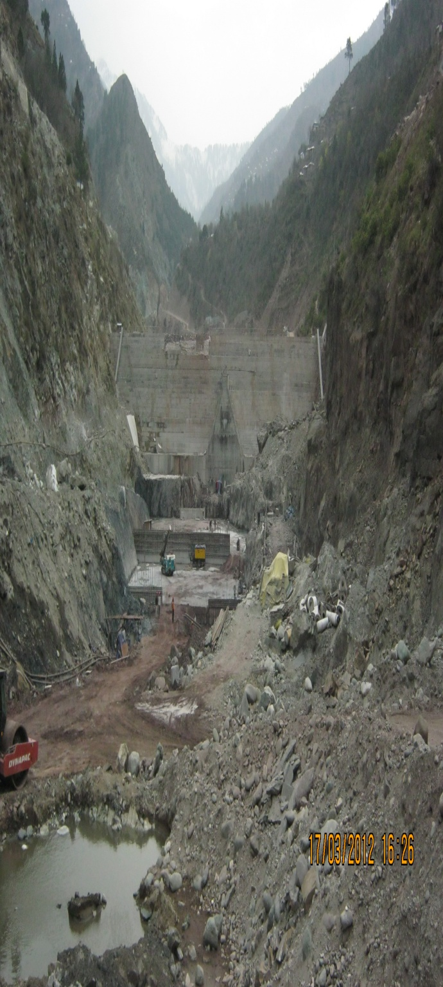

FIRST BULLETIN

MARCH 2013
LAHORE, PAKISTAN

PAKISTAN GEOTECHNICAL
ENGINEERING SOCIETY

LAHORE WALLED CITY
